**__________________________________________________________________________________**

**Emp Name** : **Radha Ankush Kadam**

**Emp Id : 46218925**

* **Why Jenkins??**

Jenkins is used to build and test your product continuously, so developers can continuously integrate changes into the build.

Jenkins is the most popular open source CI/CD tool on the market today and is used in support of DevOps,and other cloud native tools.

* **Architecture of Jenkins:**

Windows Slave Node

Jenkins Master(UI)

Apple OSX Slave Node

**TCP Connection**

Linux Slave Node

* Developers commit changes to the source code, found in the repository.
* The Jenkins CI server checks the repository at regular intervals and pulls any

newly available code.

* The Build Server builds the code into an executable file. In case the build fails,

feedback is sent to the developers.

* Jenkins deploys the build application to the test server. if the test fails,the developers are alerted.
* If the code is error free, the tested application is deployed on the production

server

* **Installation Steps:**

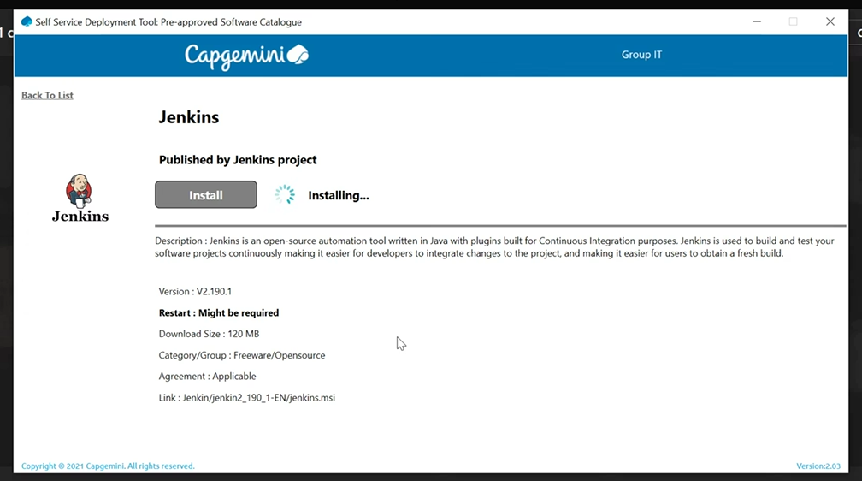

### Step 1: Download Jenkins

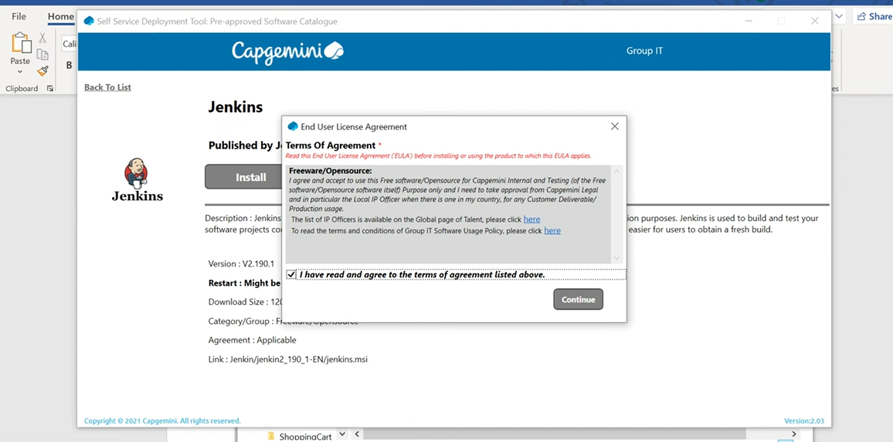

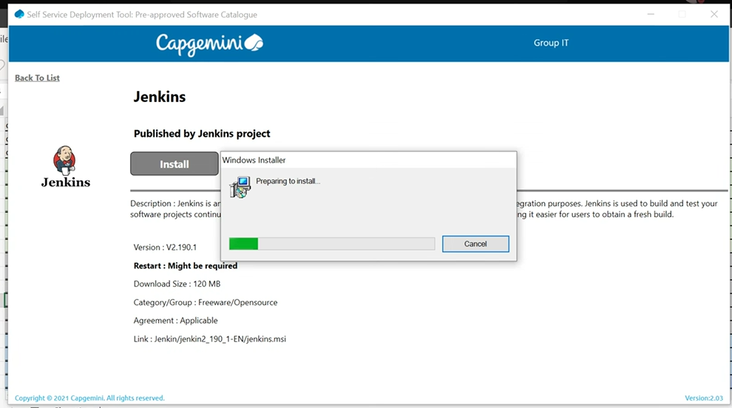

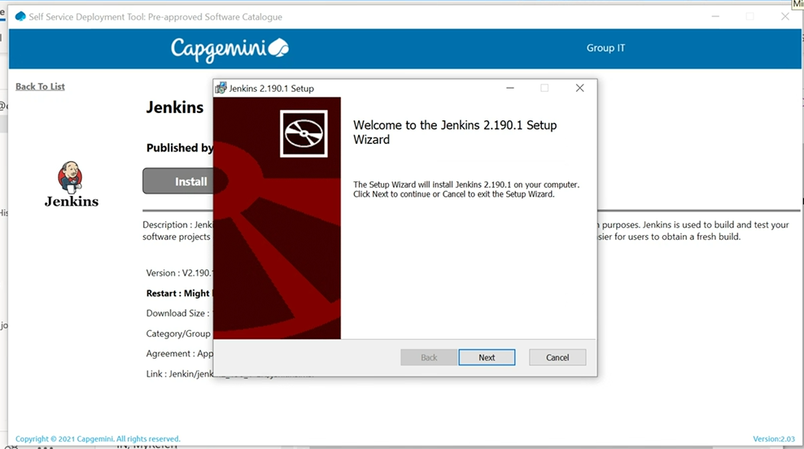

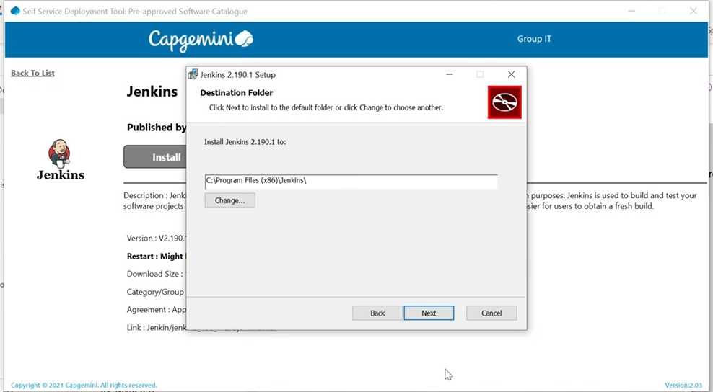

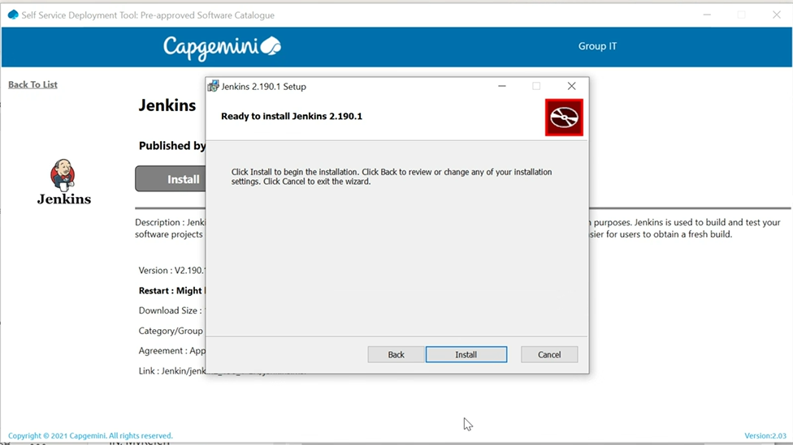

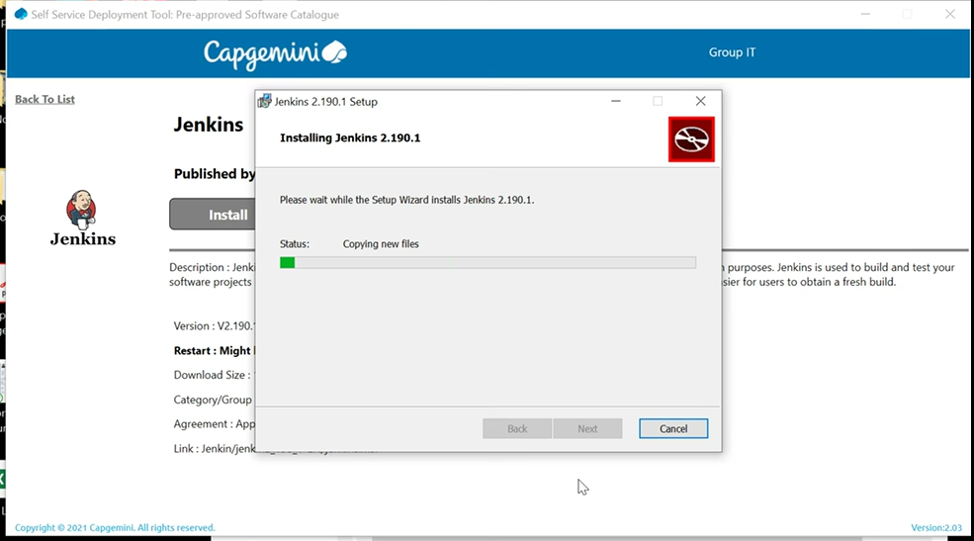

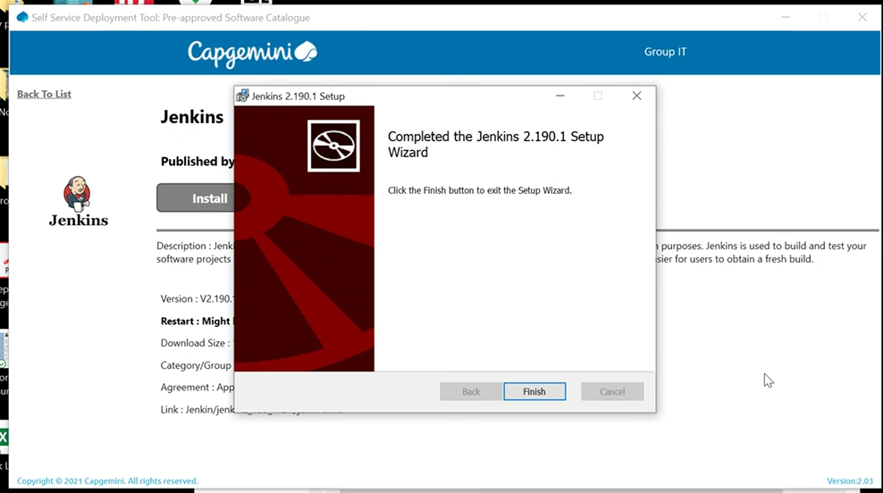

Get the installation password and then finish

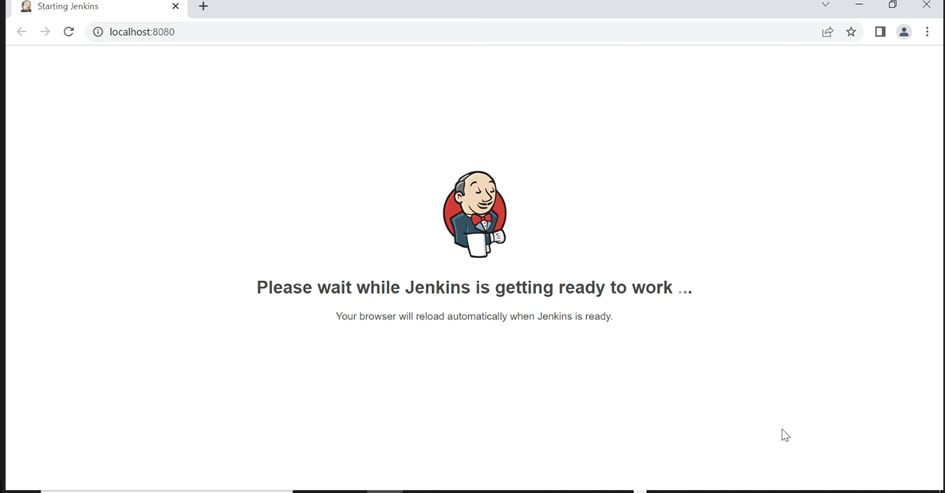

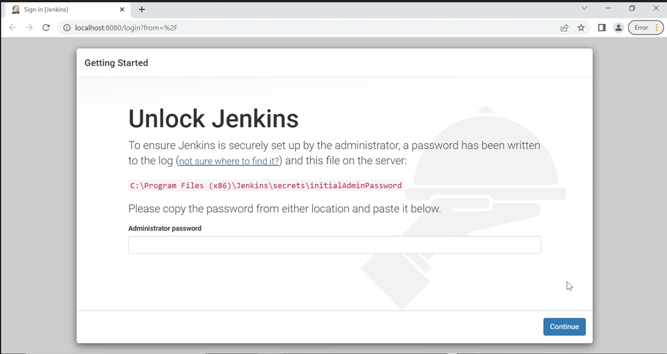

Open the below folder (as per your system folder structure) and secret key file

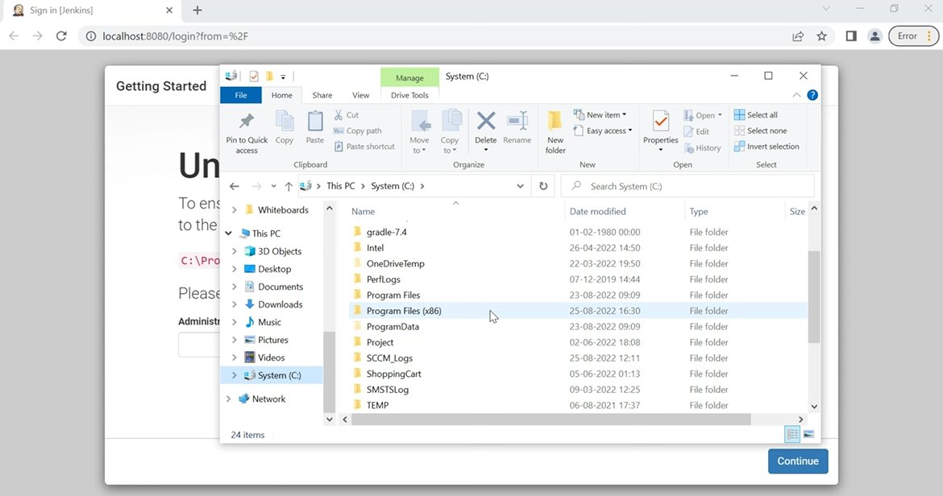

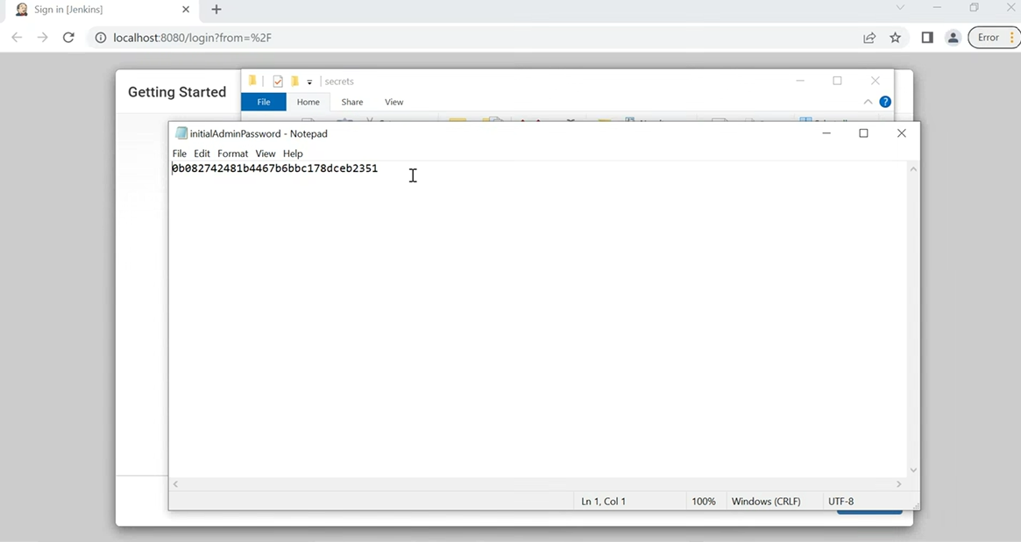

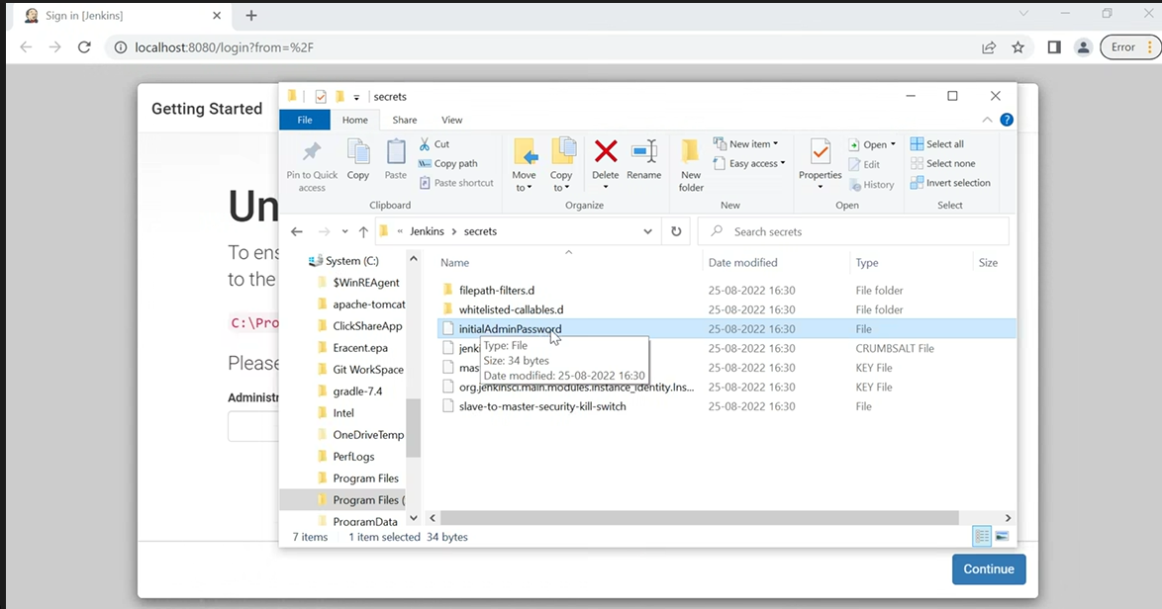

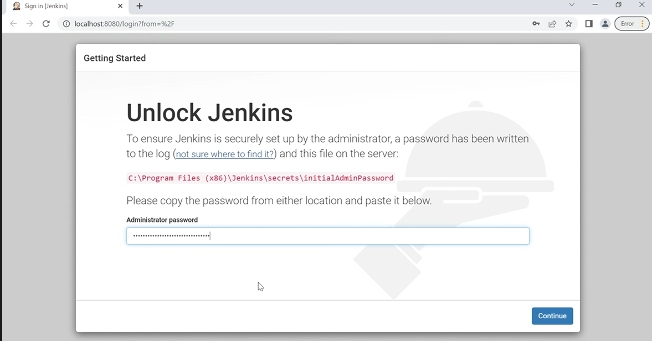

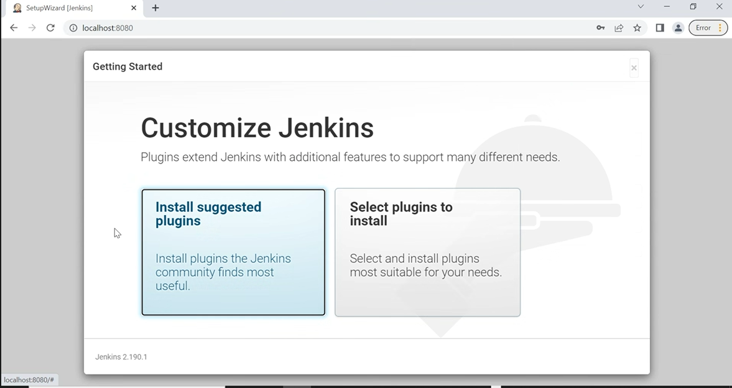

Select Install suggested plugins

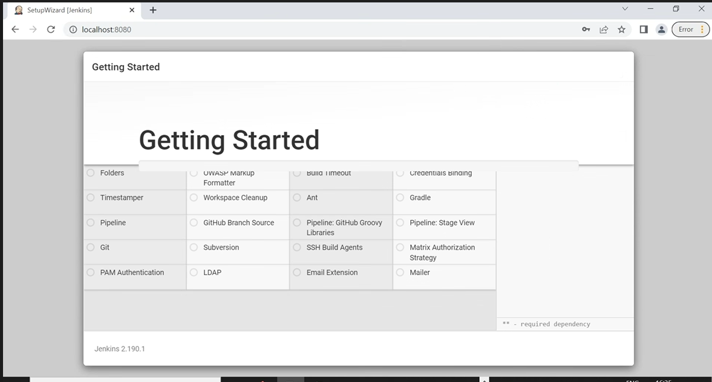

Creating a Jenkins User

Configure the Jenkins URL

### Now you are all set to use Jenkins

Start the installation process for Git

### Git was installed